Employee management System

Welcome to our employee management system. This user manual will help in using our app in the best possible way.

Let's dive deep into our application.

1. This is our home page. You have to register yourself or an admin so that an admin can manage the employees. 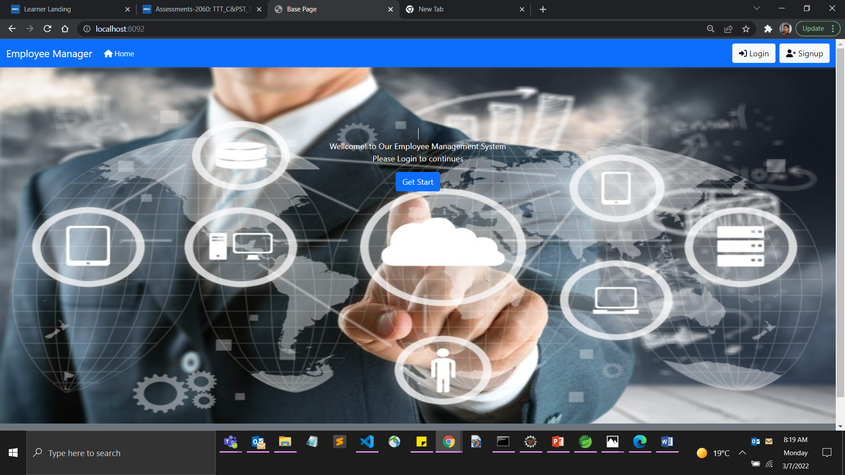
2. After clicking on get start. A registration form for admin opens. Fill the required fields.

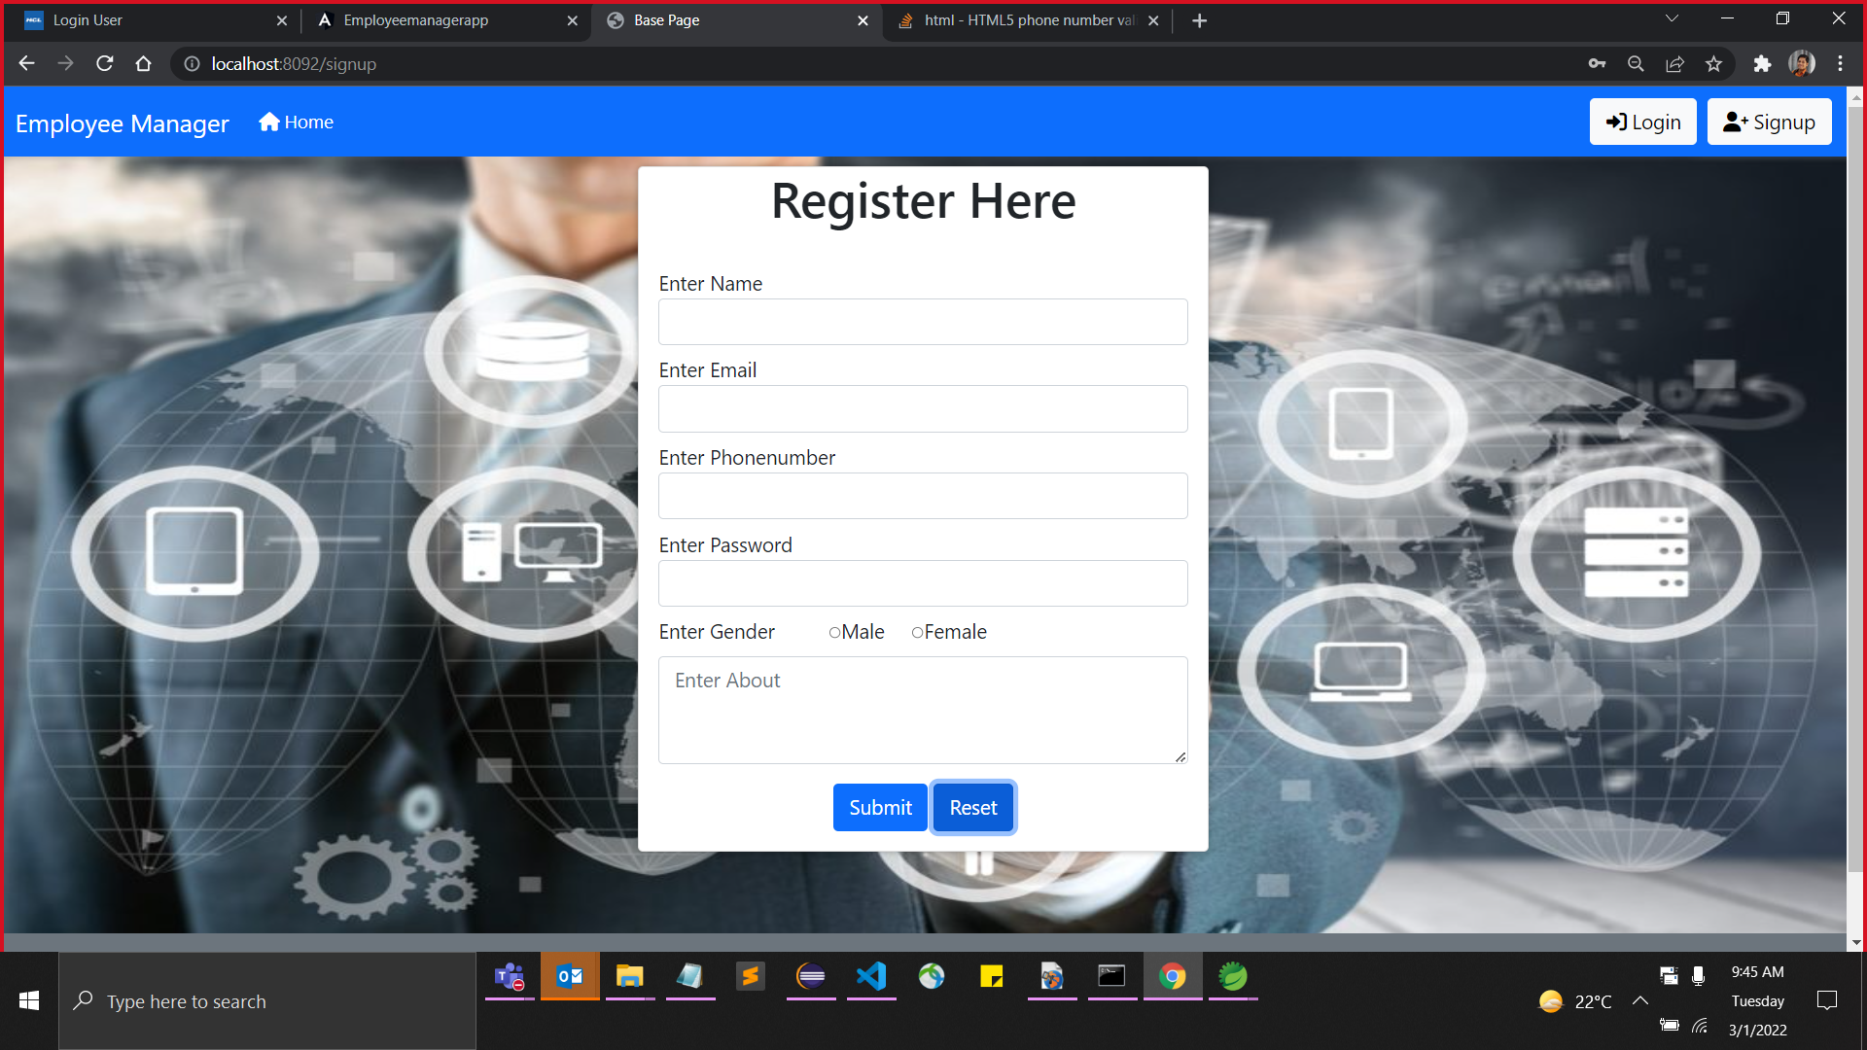

1. After successful registration and validation. An admin can login to the employee management page.

b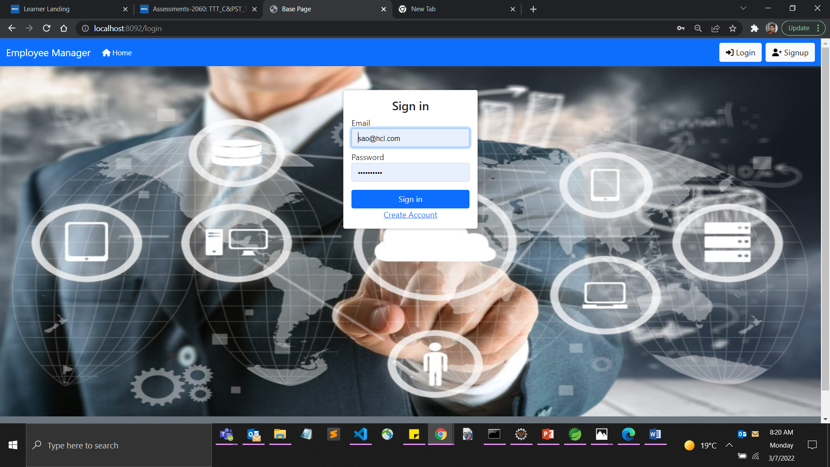

1. Click sign in to get to the management page.

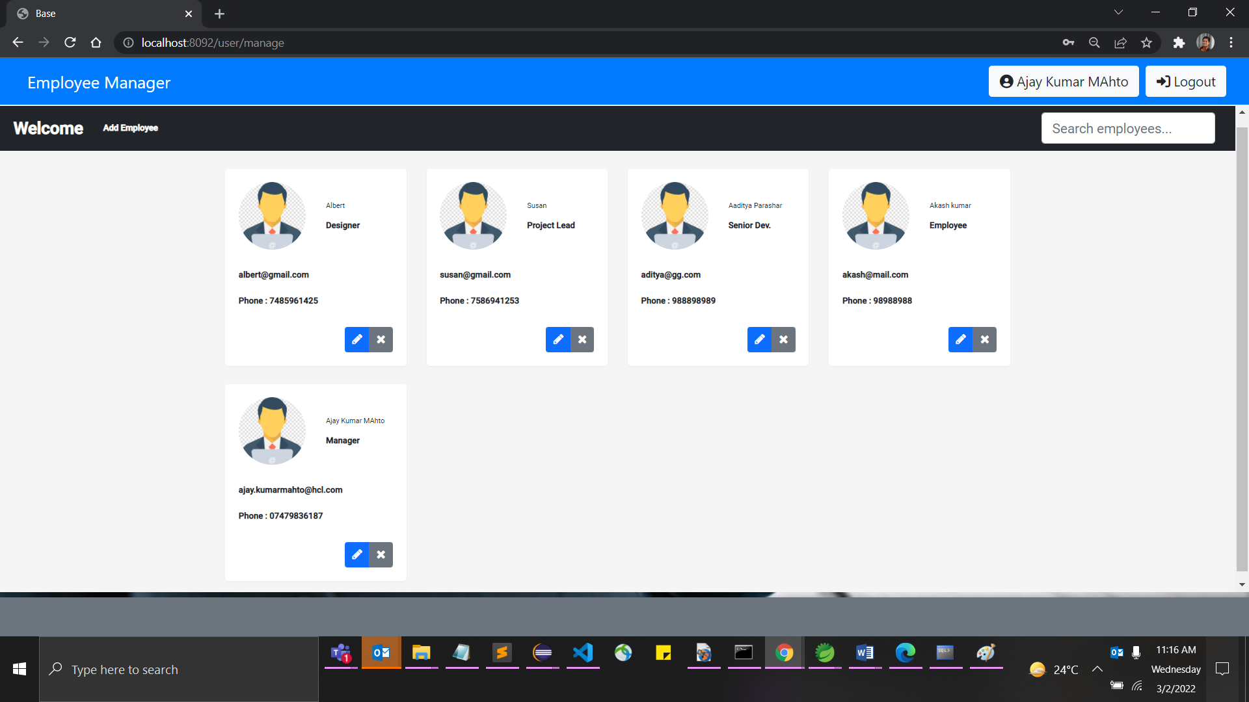

Here you get a bunch of Management tasks like updating, deleting, searching for an employee or adding an employee.

1. Adding an Employee

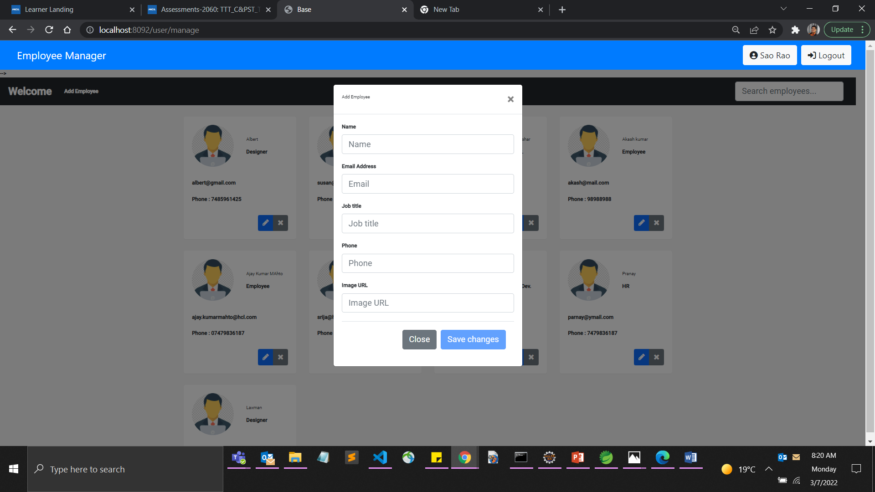

Fill all the required fields and hit submit.

1. Deleting an Employe

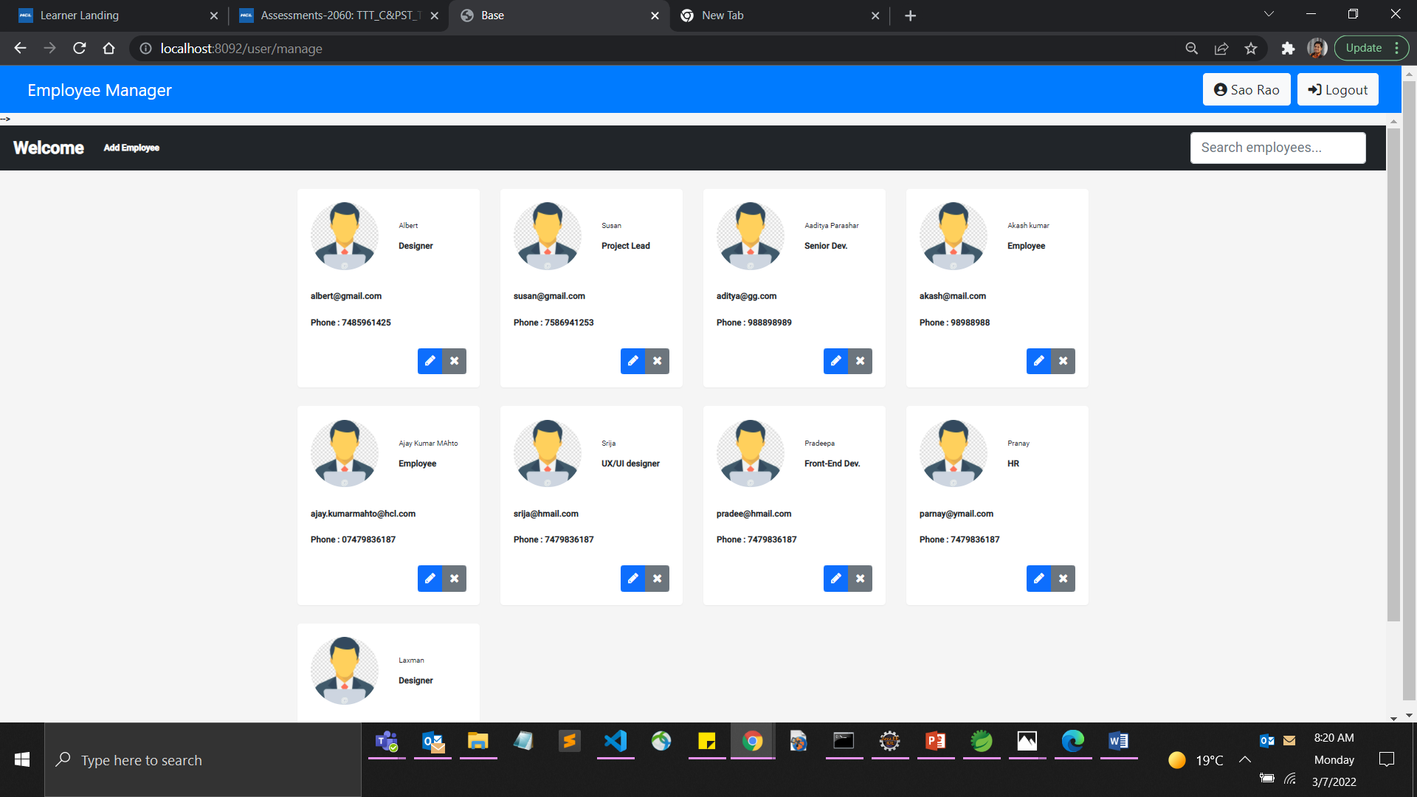

Click on cross symbol.

Following confirmation box appears.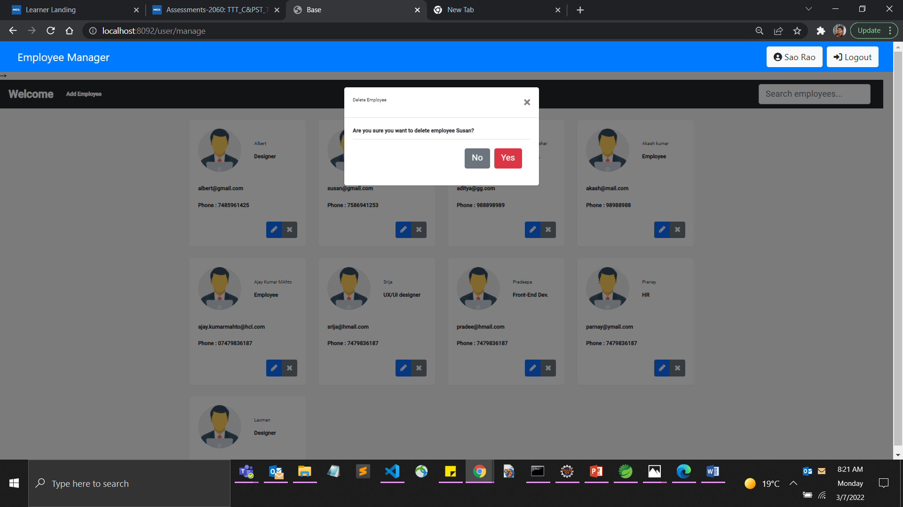

Click Yes to confirm deletion.

1. Searching for an employee.

Click on search employee.

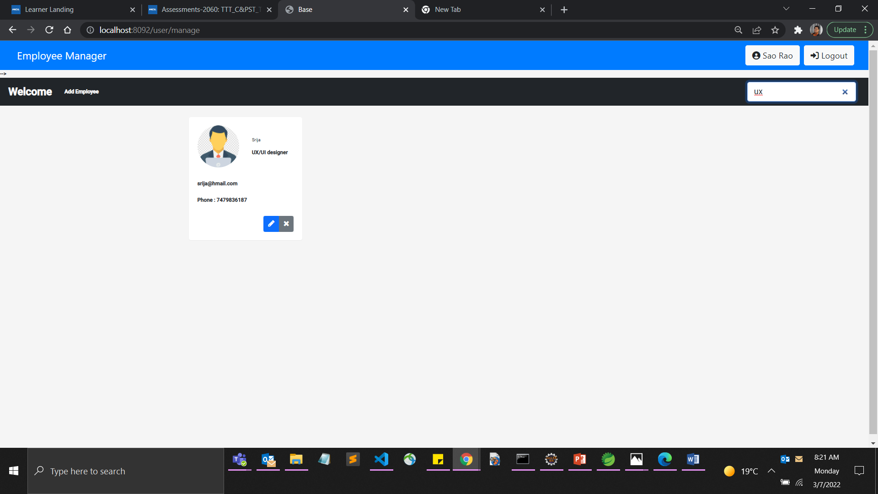

Using our Global Search feature, one can search by any field and get quick results.